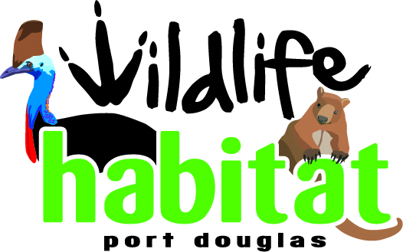

Risk Management Policy Statement

The Wildlife Habitat is committed to ensuring the safety of staff and patrons. As such, all staff under-go training in emergency procedures as a part of their induction. Procedures are reviewed annually to take into consideration workplace changes / hazards.

Michael Woodward, Director of Operations and Projects, is a fully qualified Workplace Health and Safety Officer and the Workplace Representative of the Wildlife Habitat. Regular risk assessments of the business are undertaken by senior staff and Directors.

The Wildlife Habitat conducts regular maintenance checks of equipment and infrastructure.

All staff partake in regular training on how to deal with an emergency situation.

In the event of an emergency, staff will;

- Evaluate the situation immediately
- Notify emergency services 000 fire, police, ambulance depending on the nature of the emergency. Notify Manager on duty – Chief Warden
- Ascertain if fire can be doused safely or if an evacuation is needed
- If evacuation is needed; advise supervisor and patrons immediately or as soon as practical of the situation and what rectification/actions will be taken
- If an evacuation is required patrons will be escorted to the assembly points
- Headcounts will be undertaken at muster points to ensure all patrons are accounted for
- Staff await further direction from emergency personnel

Key personnel of the Wildlife Habitat are qualified First Aid Officers in the workplace.

